ART AND HEART – THE WORLD OF ISAIAH SHEFFER
CREATIVE TEAM

Catherine Tambini (director/producer) is the Emmy Award-nominated co-producer/director of The State of Arizona, CINE Golden Eagle award, and Farmingville, winner of numerous awards including the 2004 Sundance Film Festival’s Special Jury Award. Both films appeared on PBS’s highly acclaimed documentary series Independent Lens and P.O.V., respectively.
Ms. Tambini co-produced the Academy Award-nominated documentary Suzanne Farrell: Elusive Muse, which premiered at the New York Film Festival and was shown on Great Performances/Dance in America.
Other producing credits include Varian and Putzi: A Twentieth Century Tale (feature doc) and Two Good Boys (Off-Broadway play). She field produced and shot portions of MTV’s I’m From Rolling Stone and TLC’s Pageant Perfect. She has also assisted in the production design of many well-known Hollywood films including The Hand that Rocks the Cradle, Steel Magnolias, True Colors, and The Secret of My Success.

Lenny Friedman (editor). As an award-winning commercial, documentary, and short film editor, Lenny Friedman has worked on a variety of projects including documentaries, corporate films, music videos including Randy Newman’s I Love L.A, which was nominated for best video and best editing by the American Video Awards, and short films such as The Big Day winning Best Short Film at Bucks County Film Festival and the Palm Beach Film Festival. High profile clients have included AT&T, Merrill Lynch, Pfizer, General Foods, and Teach for America, among many others.
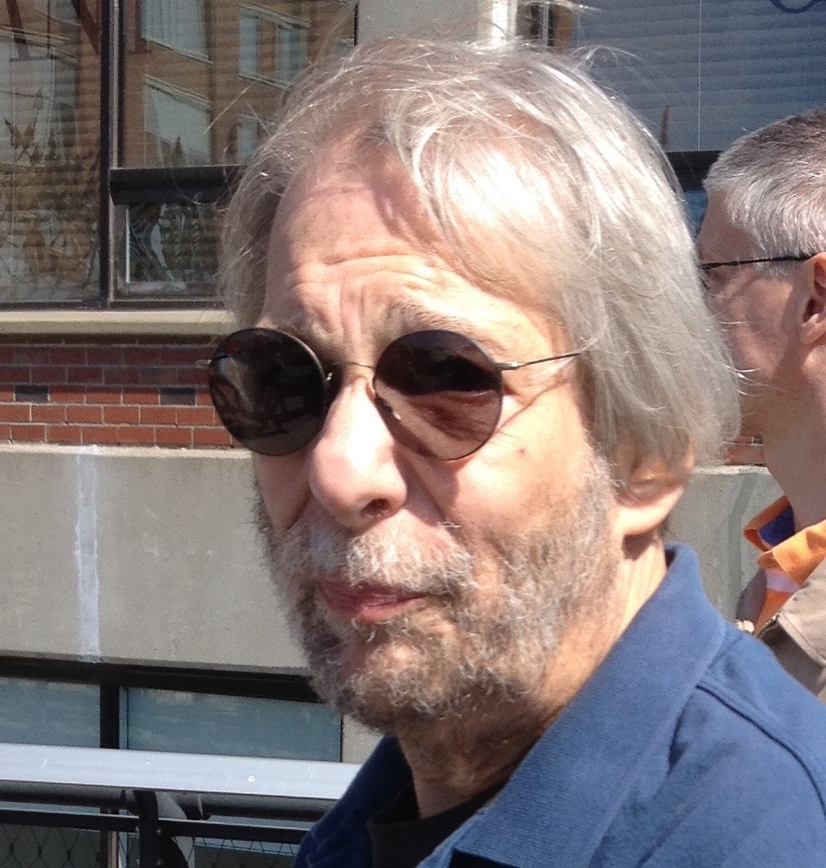

Peter Miller (sound recordist and adviser) has recorded sound on some of the most acclaimed documentaries in recent memory, including five Academy Award winners (Best Boy, The Ten Year Lunch: The Wit and Legend of the Algonquin Round Table, Into The Arms of Strangers: Stories of the Kindertransport, He Makes Me Feel Like Dancin,' and Crisis Hotline: Veterans Press 1) and two Oscar-nominees: Paul Taylor: Dancemaker and Suzanne Farrell: Elusive Muse. Other feature documentaries include Matt Heineman’s Cartel Land, Valentino: The Last Emperor, Heineman and Susan Froemke’s Escape Fire: the Fight to Rescue American Healthcare, Macky Alston’s Love Free or Die; Neil Barsky’s Koch; Barbara Kopple's Wild Man Blues; and Andre Gregory: Before and After Dinner. Mr. Miller has been nominated for eight Emmy Awards for best sound, winning for 3-2-1 Contact. Other television credits include Porgy and Bess: An American Voice; the Emmy Award-winning shows In The Fiddler's House for PBS with Itzhak Perlman and syndicated series Martha Stewart Living. He was sound supervisor on PBS’s series Broadway or Bust, among many others.
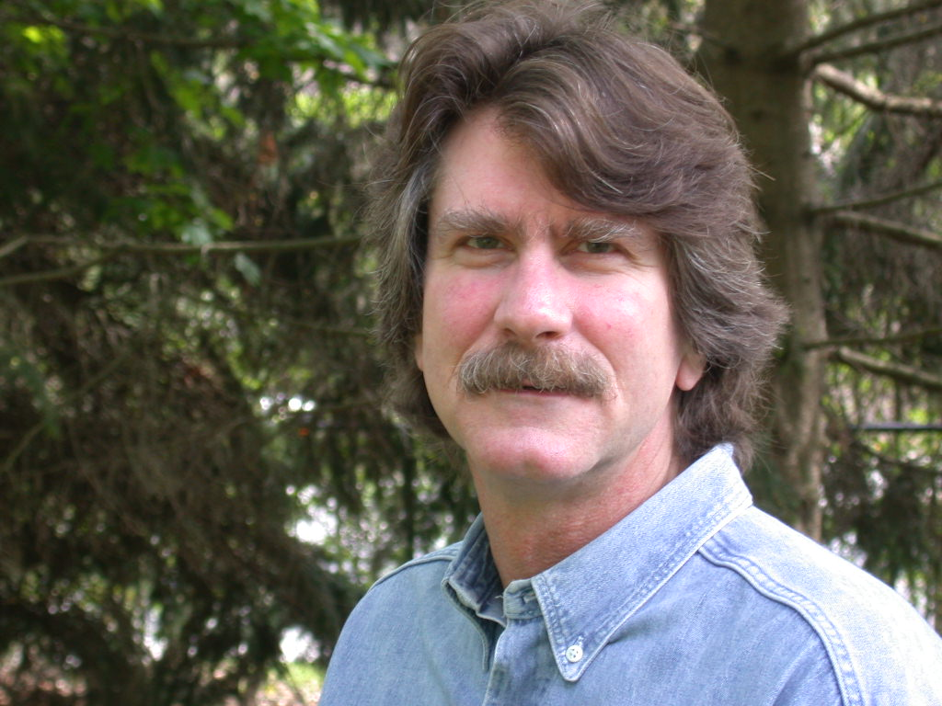

Matt Porwoll (cinematographer) is a cinematographer based in New York. His most recent work, Cartel Land, was selected for competition at the 2015 Sundance Film Festival and subsequently won the US Documentary Prize for Cinematography. This is Porwoll's second collaboration with director Matthew Heineman, after Emmy-nominated Escape Fire: The Fight to Rescue American Healthcare, shot by Wolfgang Held, which premiered at the 2012 Sundance Film Festival.
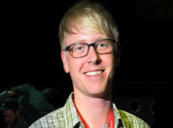
Matt has also served as an additional cinematographer on numerous other films such as HBO’s Emmy-nominated By the People: The Election of Barack Obama, directed by Amy Rice and Alicia Sams, Gunnin' For That #1 Spot directed by Adam Yauch of the Beastie Boys, and HBO’s Crisis Hotline: Veterans Press 1, directed by Ellen Goosenberg, which won the 2015 Academy Award for Best Documentary Short.

Ethel Sheffer (executive producer) is an urban planner who has worked in many neighborhoods around New York City. She has been a long-time civic activist and community leader on many of the major issues and projects on the Upper West Side. In addition to teaching at Columbia University, she has recently been appointed to the New York City Public Design Commission.
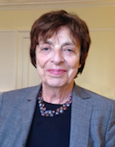
Ethel Sheffer’s new experience as the producer of the documentary about her husband, Isaiah, has been a lot of fun, some heartache, and a wonderful opportunity to experience his vitality, imagination, talents, generosity, and endless humor through the eyes of his friends and colleagues. She is grateful to all who made this happen.

Gina Leonetti Boonshoft (executive producer) was a Film/TV Assistant Director for over seventeen years. Credits (as Gina Maria Leonetti) include the films Five Corners, Outrageous Fortune, Conspiracy Theory, Married to the Mob, and Silence of the Lambs; various TV series and numerous commercials. She is the Executive Producer of the 2015 short film "First Chair" and produced the CBS Christmas Eve Special in 2010. She currently divides her time being on the Board of Directors for the West Side Campaign Against Hunger and the Nassau Alternative Advocacy Program; volunteering at St Paul and St Andrew United Methodist Church by producing their annual holiday fundraiser, tutoring and serving on church committees. She resides in NYC.

Susannah Sheffer (creative consultant). Susannah’s formative experiences included watching her father Isaiah Sheffer's theatre rehearsals and reading drafts of his scripts and lyrics. Her most recent books include Fighting for Their Lives: Inside the Experience of Capital Defense Attorneys and the poetry chapbook This Kind of Knowing. She works as an advisor and counselor at North Star, an educational program for teenagers in Western Massachusetts.

